🤖✨ Shaping the Future of Artificial Intelligence ✨🤖  
  
Hey AI enthusiasts! 🌐🚀 Excited to embark on a journey into the world of Artificial Intelligence and its incredible potential! 🤯💡  
  
🔍 Exploring the Uncharted:  
Diving deep into the realms of AI innovation, exploring the latest breakthroughs, and envisioning the possibilities that lie ahead! 🌌🚀  
  
💬 Join the Conversation:  
What do YOU think is the most exciting prospect in AI? Share your thoughts and let's spark a dialogue on shaping the future together! 💬🌐  
  
🌈 Beyond the Code:  
It's not just about algorithms and lines of code – it's about the impact on industries, society, and our daily lives! 🌍💼  
  
🚀 Tech Marvels Unleashed:  
From machine learning to robotics, witness the rise of tech marvels that are reshaping the landscape of AI. 🤖🔧  
  
🌐 Stay Tuned for Insights:  
Over the coming days, I'll be sharing snippets of knowledge, stunning visuals, and thought-provoking questions. Let's explore the limitless possibilities of AI! 🚀🔍  
  
🔗 Blogger Link :- <https://lnkd.in/dEUQkNQh>  
🔗 GitHub Link :- <https://lnkd.in/devDY7B7>  
  
[hashtag#ArtificialIntelligence](https://www.linkedin.com/feed/hashtag/?keywords=artificialintelligence&highlightedUpdateUrns=urn%3Ali%3Aactivity%3A7152369209178501120) [hashtag#FutureTech](https://www.linkedin.com/feed/hashtag/?keywords=futuretech&highlightedUpdateUrns=urn%3Ali%3Aactivity%3A7152369209178501120) [hashtag#AIInnovation](https://www.linkedin.com/feed/hashtag/?keywords=aiinnovation&highlightedUpdateUrns=urn%3Ali%3Aactivity%3A7152369209178501120) [hashtag#TechEnthusiast](https://www.linkedin.com/feed/hashtag/?keywords=techenthusiast&highlightedUpdateUrns=urn%3Ali%3Aactivity%3A7152369209178501120) [hashtag#StayCurious](https://www.linkedin.com/feed/hashtag/?keywords=staycurious&highlightedUpdateUrns=urn%3Ali%3Aactivity%3A7152369209178501120) [hashtag#FutureOfTech](https://www.linkedin.com/feed/hashtag/?keywords=futureoftech&highlightedUpdateUrns=urn%3Ali%3Aactivity%3A7152369209178501120) [hashtag#AICommunity](https://www.linkedin.com/feed/hashtag/?keywords=aicommunity&highlightedUpdateUrns=urn%3Ali%3Aactivity%3A7152369209178501120)

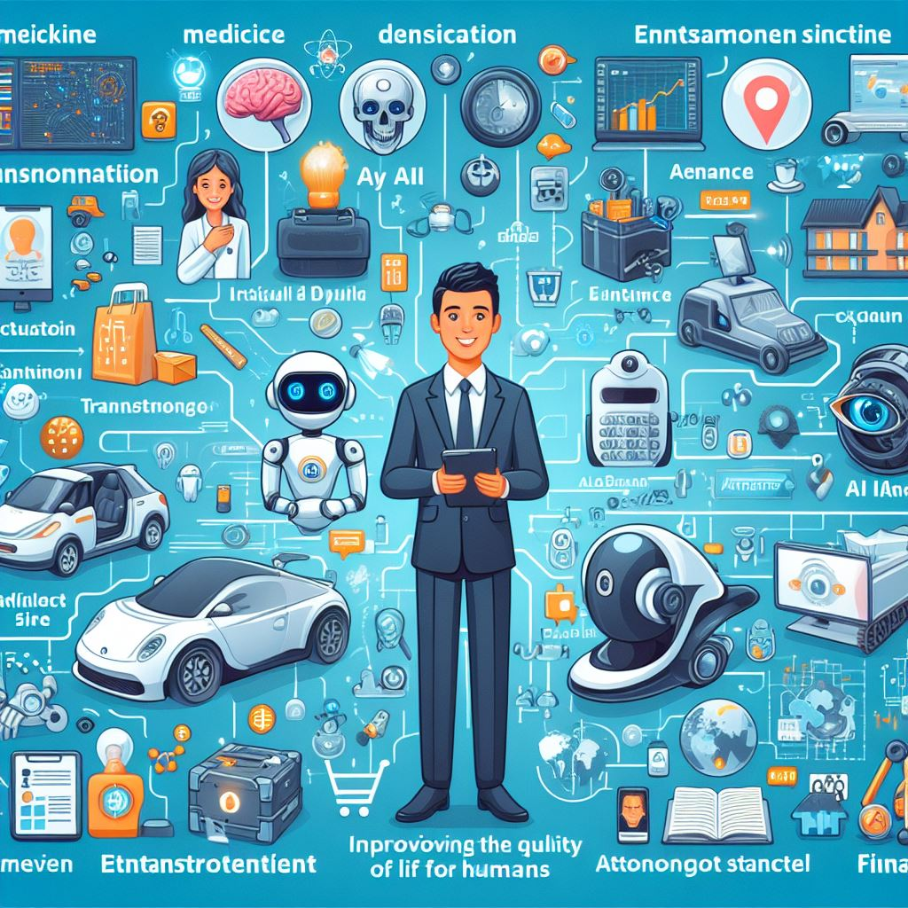

LinkedIn Post Link :- https://www.linkedin.com/posts/shree-sapre-067057272_artificialintelligence-futuretech-aiinnovation-activity-7152369209178501120-9SOy?utm_source=share&utm_medium=member_desktop